Main Page.html (Home Page)

Aboutus.html
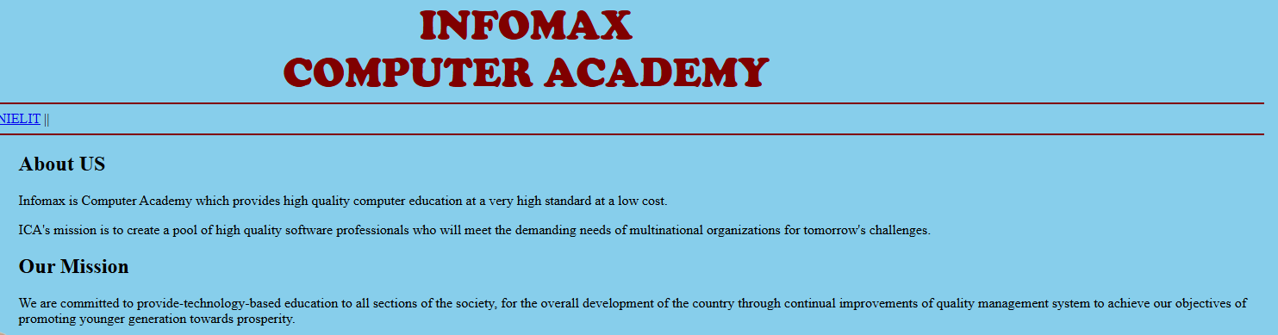
Home.html


Courses.html

Create Navigation back to Mainpage.html from all the other pages.

